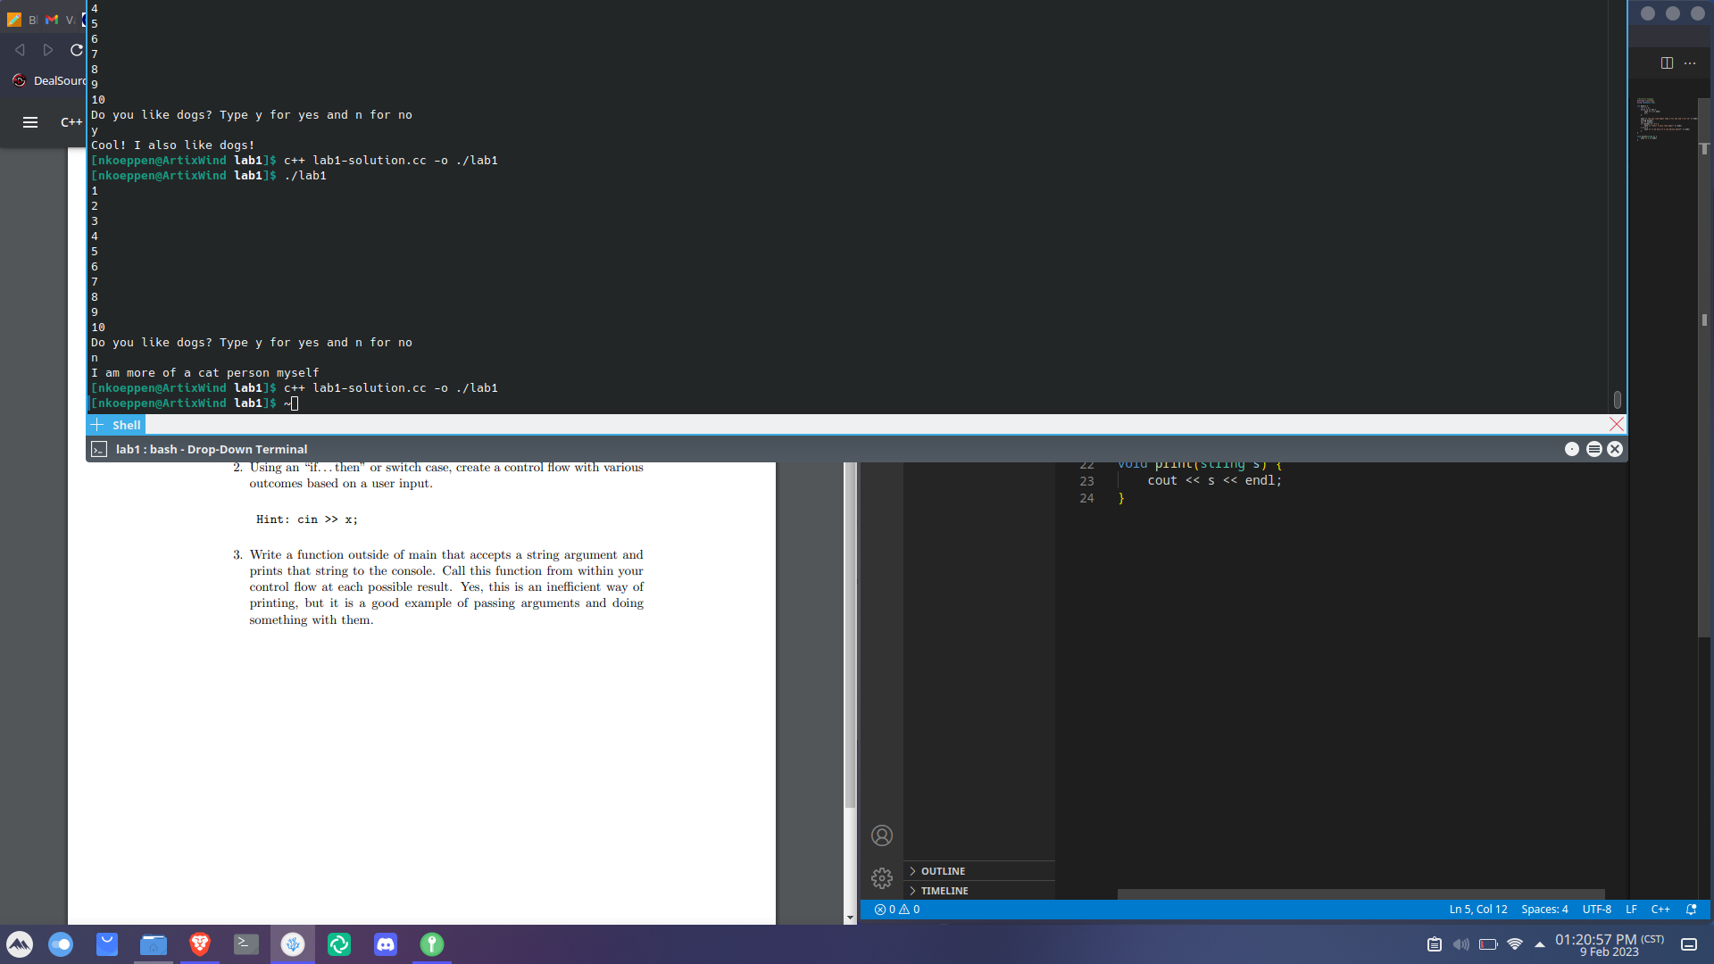
//Nicholas Koeppen
#include <iostream>
using namespace std;

int main() {
int i = 1;
while (i <= 10) {
cout << i << endl;
i++;
}

cout << "Do you like dogs? Type y for yes and n for no" << endl;
string answer;
cin >> answer;
if (answer == "y") {
cout << "Cool! I also like dogs!" << endl;
} else {
cout << "I am more of a cat person myself" << endl;
}
}

void print(string s) {
cout << s << endl;
}

